Match the picture of the food/drink to the country

1. Banitsa

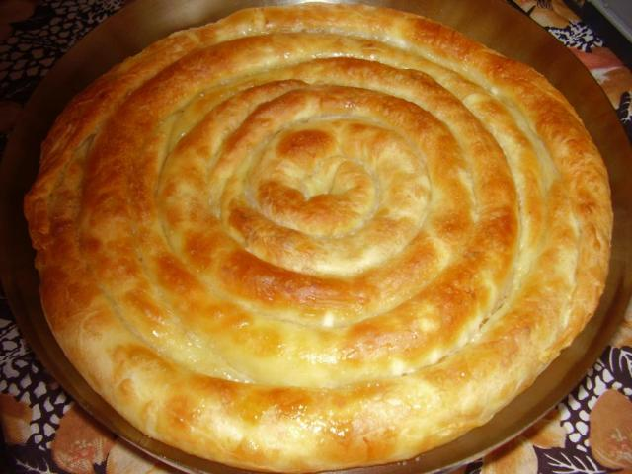

a. Romania

b. Bulgaria

c. Poland

d. Italy

Answer: b

2. Shopska Salad

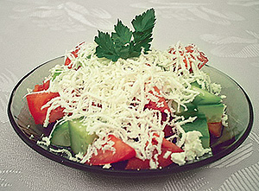

a. Bulgaria

b. Spain

c. Sweden

d. Turkey

Answer: a

3. Yoghurt

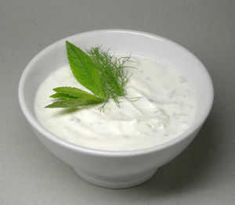

a. Romania

b. Poland

c. Spain

d. Bulgaria

Answer: d

4. Luytenitza

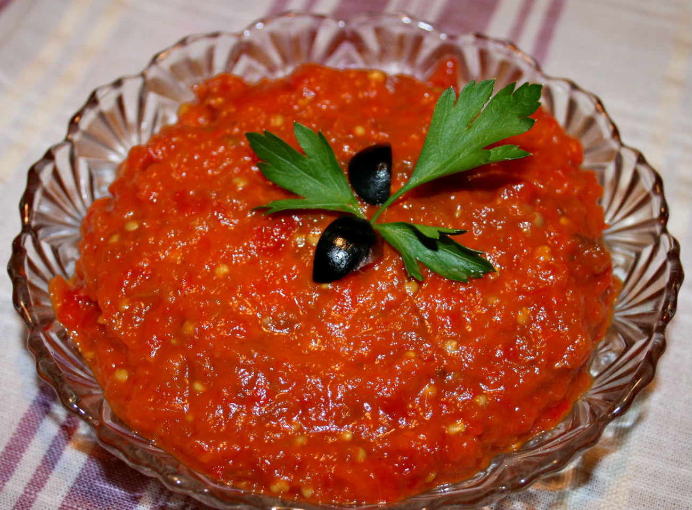

a. Turkey

b. Italy

c. Bulgaria

d. Sweden

Answer: c

5. Guyvech

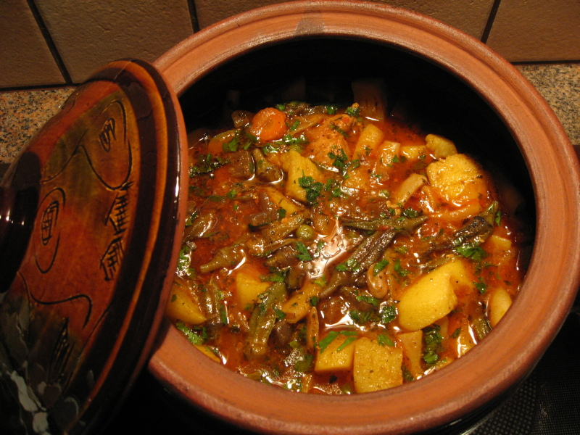

a. Bulgaria

b. Italy

c. Romania

d. Poland

Answer: a

**Sources:**

**Banitsa:**

<http://www.google.bg/imgres?hl=bg&client=firefox-a&tbo=d&rls=org.mozilla:en-US:official&biw=1280&bih=865&tbm=isch&tbnid=dLHhVMXATGEdRM:&imgrefurl=http://www.vsekiden.com/84373/%25D0%25BA%25D1%258A%25D1%2581%25D0%25BC%25D0%25B5%25D1%2582%25D0%25B8-%25D0%25B7%25D0%25B0-%25D0%25B1%25D0%25B0%25D0%25BD%25D0%25B8%25D1%2586%25D0%25B0/&docid=vCYgT-WHKHpQlM&imgurl=http://www.vsekiden.com/imgs/mejdunarodni/banica.jpg&w=300&h=228&ei=pR_rUJTSJoXDtQbumoHgBQ&zoom=1&iact=hc&vpx=4&vpy=403&dur=1370&hovh=182&hovw=240&tx=84&ty=104&sig=116094138080118387978&page=3&tbnh=142&tbnw=191&start=68&ndsp=37&ved=1t:429,r:92,s:0,i:403>

**Shopska salad:**

<http://www.google.bg/imgres?hl=bg&client=firefox-a&hs=eWJ&tbo=d&rls=org.mozilla:en-US:official&biw=1280&bih=865&tbm=isch&tbnid=LE04B6TYxnl36M:&imgrefurl=http://infobulgaria.info/bgsimvoli/symbols.php&docid=-DxUuV335M0UvM&imgurl=http://infobulgaria.info/bgsimvoli/pics/24.jpg&w=300&h=221&ei=5R7rUJGnF43HswbmkIHwDA&zoom=1&iact=hc&vpx=143&vpy=437&dur=1411&hovh=176&hovw=240&tx=115&ty=100&sig=116094138080118387978&page=1&tbnh=141&tbnw=195&start=0&ndsp=30&ved=1t:429,r:13,s:0,i:121>

**Yoghurt:**

<http://yogurt-milk.com/%D0%BA%D0%B8%D1%81%D0%B5%D0%BB%D0%BE-%D0%BC%D0%BB%D1%8F%D0%BA%D0%BE/>

**Luytenitza**

<http://sotkiradosti.ru/kulinariya/lyutenitsa>

**Guyvech**

<http://www.referati.org/bylgarska-nacionalna-kuhnq/45223/ref/p10>